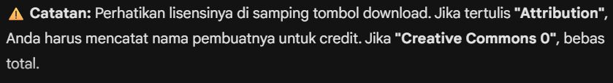
SFX_Spawn_Trash (Mesin)
- Short hydraulic pump action by jorickhoofd -- https://freesound.org/s/170742/ -- License: Attribution 4.0

